NORTHEAST REGIONAL NEWS

NORTHEAST REGIONAL CREDIT UNION’S NEWSLETTER

March 2021

Summer Skip-A-Payment
Application on back
page
Northeast Regional Credit Union is now offering
the Summer Skip-A-Payment promotion.
By signing up, we will allow you to skip your July or August payment.

The processing fee is 10% of your loan payment, up to a maximum of $50 per loan.
Only one skip-a-pay is allowed per calendar year on collateral secured loans.
*Must meet eligibility requirements.
SPRING LOAN PROMOTION
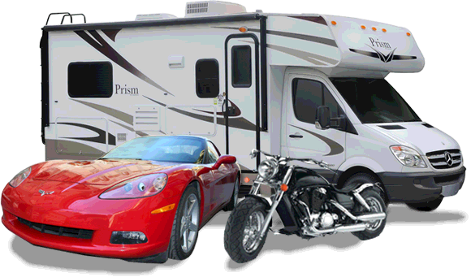

New & Used Autos As Low As
2.00% APR

New & Used RV, Boat, Motorcycles As Low As
3.00% APR

Subject to underwriting guidelines and approval. Must be a new purchase or refinance from another financial institution. Offer subject to change without notice.

Northeast Regional  Credit Union  514A Broadway  PO Box 1105  Hannibal, MO 63401  Phone (573) 221-0201  Fax (573) 221-0201  E-mail: nercu@hotmail.com  www.mynrcu.com  Office Hours:  Monday – Friday  11:00 a.m. – 4:00 p.m.  __________________________  HOLIDAY CLOSINGS  May 31 – Memorial Day  July 5 – Independence Day |  | CASH PRIZES!

